GRADE 11
QUESTION PAPER

SUBJECT | : | Life Sciences
TASK | : | June Examination  2016
MARKS | : | 150
TIME | : | 2½ Hours

This paper consists of 17 pages

INSTRUCTIONS AND INFORMATION:

Read the following instructions carefully before answering the questions.

1. Answer ALL the questions in the ANSWER BOOK provided.

2. Start the answer to EACH question at the top of a NEW page.

3. Number the answers correctly according to the numbering system used in this question paper.

4. Present your answers according to the instructions of each question.

5. If answers are not presented according to the instructions of each question, candidates will lose marks.

6. ALL drawings should be done in pencil and labelled in blue or black ink.

7. Draw diagrams or flow charts only when requested to do so.

8. The diagrams in this question paper may NOT necessarily be drawn to scale.

9. The use of graph paper is NOT permitted.

10. Non-programmable calculators, protractors and compasses may be used.

11. Write neatly and legibly. Candidates will lose marks for slovenly and illegible work.

SECTION A
QUESTION 1
1.1 Various options are provided as possible answers to the following questions. Choose the most correct answer and write only the letter (A to D) next to the question number (1.1.1 – 1.1.9) in the ANSWER BOOK, for example
1.1.10. D

1.1.1 Which one of the following is not found in bryophytes?
A Sori B Spores
C Sporangia D Seeds
1.1.2 An ovary would be found in…….
A Gymnosperms B Angiosperms
C Bryophytes D Pteridophytes
1.1.3 Antibodies are proteins that……..
A Break down pathogens B Catalyse biochemical reactions

C Are produced by T-cells that kill D Bind with specific antigens
disease causing virus

1.1.4 A biologist discovered a new living cell with a distinct cell wall but with no definite nucleus. The cell is likely to be that of a/an …
A Animal B Plant
C Virus D Bacterium

1.1.5 The following are involved in the process of cellular respiration:
1. Energy
2. Carbohydrates
3. Carbon dioxide
4. Water
5. Oxygen

Which ONE of the following equations correctly represents their involvement in the process of cellular respiration?

A 2+3=1+4+5 B 2+4=1+3+5
C 1+2=3+4+5 D 2+5=1+3+4

1.1.6 A phase that forms part of cellular respiration is the …
A Krebs cycle B Dark phase

C Light-independent phase D Light phase

1.1.7 The apparatus drawn below is used to show that carbon dioxide is given off during respiration.

A suitable control for this investigation would be to …
A Leave out the stopper B Cover the test tube with black
paper
C Use bean seeds instead of pea D use boiled seeds which have
seeds been sterilized

QUESTIONS 1.1.8 and 1.1.9 ARE BASED ON THE FOLLOWING

The graph below shows the results of an investigation into the effect of carbon dioxide concentration on the rate of photosynthesis. The investigation was carried out under conditions of bright light. It was then repeated, using the same materials and under the same conditions, but in light of medium intensity.

1.1.8 What factor was limiting the rate of photosynthesis during the period marked X?
A Light B Carbon dioxide

C Enzymes D Water

1.1.9 What factor was limiting the rate of photosynthesis during the period marked Z?

A Light B Carbon dioxide

C Enzymes D Water

(9 × 2) (18)

1.2 Give the correct biological term for each of the following descriptions.
Write only the term next to the question number (1.2.1 to 1.2.8) in the ANSWER BOOK.

1.2.1 Type of asexual reproduction in which a bacteria splits in to two, as in mitosis.

1.2.2 Acquired immunity obtained through artificial means via a weakened form of a pathogen.

1.2.3 Folded structures found on the inner membrane of a mitochondria.

1.2.4 Organelle in which cellular respiration takes place.

1.2.5 Expected colour change of diluted iodine solution when the presence of starch in leaf is confirmed.
1.2.6 Process during photosynthesis in which water molecules are split into hydrogen and oxygen using radiant energy.

1.2.7 The gas which is essential for Kreb’s cycle to occur.

1.2.8 Light independent phase in photosynthesis
(8 × 1) (8)

1.3 Indicate whether each of the statements in COLUMN I applies to A only, B only, Both A and B, or None of the items in COLUMN II. Write A only, B only, Both A and B, or None next to the question number (1.3.1 to 1.3.7) in the ANSWER BOOK.

COLUMN 1  STATEMENT |  | COLUMN II  ITEM
1.3.1 | Molecule that stores energy | A | ATP
1.3.1 | Molecule that stores energy | B | ADP
1.3.2 | The fuel required for cellular respiration | A | Glycogen
1.3.2 | The fuel required for cellular respiration | B | Glucagon
1.3.3 | Products of anaerobic respiration in yeast | A | Alcohol
1.3.3 | Products of anaerobic respiration in yeast | B | CO₂
1.3.4 | The organelle in which photosynthesis takes place | A | Mitochondria
1.3.4 | The organelle in which photosynthesis takes place | B | Chloroplast
1.3.5 | Storage of chlorophyll | A | Grana
1.3.5 | Storage of chlorophyll | B | Lamella
1.3.6 | Acid secreted in the stomach during digestion. | A | HCL
1.3.6 | Acid secreted in the stomach during digestion. | B | Fatty acid
1.3.7 | Ectoderm, mesoglea and endoderm | A | Triploblastic
1.3.7 | Ectoderm, mesoglea and endoderm | B | Diploblastic

(7 × 2) (14)

1. 4 Study the phylogenic tree below and answer the following questions.

    - What animal group(s)
- Has no nervous system? (1)
- Has a nervous system but no exoskeleton or vertebrae? (1)
- Has a nervous system and exoskeleton? (1)
- Has jaws, hair and is therefore endothermic? (1)
- Has feathers? (1)

    - Which group of mammals does not have a placenta? (1)

    - Which property in this phylogenic tree, distinguishes between crocodiles
and birds? (1)

    - If A has a hypothetical common ancestor, which animal group(s) evolved
from it? (1)

    - Name TWO properties in this phylogenic tree that all mammals have in
common? (2)
(10)

TOTAL QUESTION 1: 50

TOTAL SECTION A: 50

SECTION B

QUESTION 2

2.1 Study the parts of the fern’s life cycle below and answer the questions that follow.

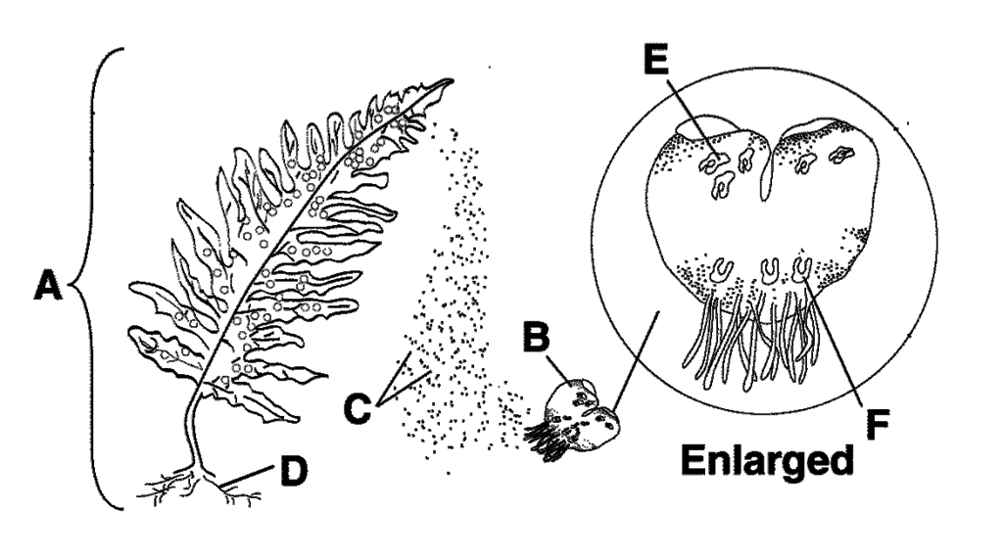

2.1.1. Which generation (A or B) is poorly adapted for terrestrial life? | (1)
2.1.2. State whether the following structures are haploid or diploid: | (1)
a) D | (1)
b) F | (1)
2.1.3. Identify structure F. | (1)
2.1.4. Why are structures E and F found on the ventral surface of B? | (2)
(6)

2.2. The image below represent various types of malnutrition. Study the images
and answer the questions.

2.2.1. Identify the type of malnutrition illustrated by images A, B and C
respectively. (3)

2.2.2. What is the main cause of the conditions shown in images B and C? (2)
(5)

2.3. The accompanying diagram represents a structure associated with the
human digestive system. Study the diagram and answer the questions
that follow.

2.3.1. Identify the above structure. (1)

2.3.2. In which organ is this structure found? (1)

2.3.3. What is the main function of the structure shown in the above figure? (1)

2.3.4. Name TWO substances which are found in higher concentration in C than
than in D (2)

2.3.5. Label parts A, B and E (3)

2.3.6. State any THREE structural features of the above diagram that enables it
to perform its function effectively. (6)
(14)

2.4. In an investigation to determine the action of the enzyme amylase on starch, a
group of learners used a shallow dish with agar (jelly-like growth medium) which
contained starch. Four holes were cut into the agar and each was filled with a
different liquid as indicated in the diagram below.

The dish was covered and incubated at 37°C for 24 hours, iodine solution was
Poured over the surface of agar.

The results are indicated below.

2.4.1. Explain the results at:
  - B (2)
  - C (2)
  - D (2)

2.4.2. Each learner in the group conducted his/her own investigation because they
wanted to compare their results. List TWO factors that they needed to keep
the same in order to make a valid comparison. (2)
(8)

2.5. The diagram A below shows a complete animal while B shows a cross section
through the main body stalk. Study the diagrams below and answer the
questions that follow.

2.5.1. Identify the phylum to which this organism belongs. (1)

2.5.2. Name the kind of symmetry shown in this organism. (1)

2.5.3. Explain the advantage this symmetry has for the mode of living of this
organism. (2)

2.5.4. Name THREE phyla that you have studied, which have a coelom. (3)
(7)

TOTAL QUESTION 2 [40]

QUESTION 3

3.1. Study the table below showing the prevalence of influenza amongst learners in a high school in North West. There were a total of 325 boys and 392 girls in the school during the period of the survey.

Month | Boys infected with influenza | Girls infected with influenza
April | 5 | 17
May | 32 | 59
June | 71 | 88
July | 65 | 75
August | 10 | 5

3.1.1. Give one reason why girls had a higher rate of infection than boys. 2)

3.1.2. What percentage of boys was infected by the influenza virus in July?
Show all calculations. 3)

3.1.3. A flu vaccine was administered in July. Was it effective?
Justify your answer. 3)

3.1.4. Why would these learners need to be vaccinated every year to
reduce the risk of getting influenza? 2)
(10)

3.2. Bazaruto was home to over half a million people in 2007. This area lies on the outskirts of Bujumbura. Water comes from shared taps, as one in three people have no access to water at his or her home. The population is growing by 48 000 people every year. The area is divided into regions called site A, site B and site C. Research in site B and C shows that there is one toilet for every 105 people. The table that follows lists the top four causes of death for children under the age of one in the area. Note that diarrhoea did not feature as a cause of death in any of the middle-class or upper class suburbs of Bujumbura.

Table showing the top four causes of death among children under one years old in 2008 and 2010 in Bazaruto.

Category | 2008 | 2010
Diarrhoea and gastro-enteritis | 19,2% | 21,3%
HIV/AIDS | 11,7% | 16,1%
Pneumonia | 9,2% | 6,6%
TB | 8,9% | 13,3%

3.2.1. Plot a bar graph of the data provided. 8)

3.2.2. Which positive trend took place between 2008 and 2010 (according to the data)? 2)

3.2.3.Does this data suggest a link between HIV/AIDS and TB? Explain your answer. 3)

3.2.4.In what scientific way could this data have been collected? (1)
(14)

3.3. When light shines on pondweed Elodea sp, bubbles of gas are released.
The rate at which bubbles of gas are produced can be used to measure
The rate of photosynthesis.

An investigation was carried out to study the effect of different colours
Of light on the rate of photosynthesis in the pondweed.

  - The pondweed was exposed to one colour of light and left for 5 minutes
before measurements were taken.
  - The time taken for the release of 20 bubbles was recorded.
  - The procedure was repeated using light of a different colour of equal
Intensity.
  - The apparatus was set up as shown in the diagram below.

The results are shown in the table below

COLOUR OF LIGHT | TIME TAKEN TO  RELEASE 20 BUBBLES  (SECONDS)
Violet | 80
Blue | 40
Green | 160
Yellow | 140
Red | 70

3.3.1. Which colour light is the best for photosynthesis? (1)

3.3.2. Calculate the average time taken for the release of 20 bubbles for
all colours. Show all working. (3)

3.3.3. Express bubble production under violet, blue and green light as a
ratio. (2)

3.3.4. Explain why the apparatus is left for 5 minutes under each color
of light before taking measurements. (2)

3.3.5. Without modifying the apparatus, how could the reliability of the
results be increased? (1)
(9)
3.4. Tabulate THREE differences between aerobic and anaerobic
respiration. (7)

TOTAL QUESTION 3 [40]

SECTION C

QUESTION 4
In plants pollen transfer and seed dispersal requires special agents like insects, birds and bats. Define pollination and describe the different features of insect and wind pollinated flowers.
(17)

Synthesis (3)
(20)

NOTE: NO marks will be awarded for answers in the form of flow charts or diagrams.

