SEDIBENG WEST DISTRICT
MID YEAR EXAMINATION

GRADE 12

AGRICULTURAL SCIENCES

JUNE 2016

MARKS : 150

TIME : 2 ½ hours

This question paper consists of 14 pages

INSTRUCTIONS AND INFORMATION
Read the following instructions carefully before answering the questions

1. Answer ALL the questions.
2. Write ALL the answers in the ANSWER BOOK.
3. Start the answers to each question at the top of a NEW page.
4. Number the answers correctly according to the numbering system used in this question
paper.
5. Present your answers according to the instructions of each question.
6. ALL drawings should be done in pencil and labeled in blue or black ink.

7. Only draw diagrams or flow charts when asked to do so.

8. The diagrams in this question paper are NOT all drawn to scale.
9. Do NOT use graph paper.
10. Non-programmable calculators, protractors and compasses may be used.
11. Write neatly and legibly.

SECTION A
QUESTION1
  - Various options are provided as possible answers to the following
questions. Choose the correct answer and write only the letter (A to
D) next to the question number (1.1.1 to 1.1.7), for example 1.1.7 D
1.1.1 The process that involves the removal of undigested food
from the anus called…..
- egestion
- excretion
- secretion
- digestion
1.1.2 Kwashiorkor is a diseases caused by a deficient in …..
- Kilojoules
- Carbohydrates
- Vitamins and nutrients
- protein
1.1.3 Name the microorganism that is not classified into a
kingdom
- Fungus
- Virus
- Bacterium
- Protozoan

1.1.4 The short lived type of immunity that a mothers pass to their
babies is called … immunity
- maternal
- active
- passive
- innate
1.1.5 Which of the following is present in the bryophytes?
- Seeds
- Spores
- Xylem
- Flowers
1.1.6 The diagram below shows an experimental set up of
photosynthesis
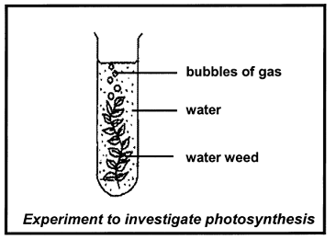
Which conditions will cause plant to produce most
bubbles?
Dissolved CO₂ Light Temperature
- Absent dim warm
- Present bright warm
- Present dim cool
- Present bright cool
1.1.7 A group of grade 11 leaners decided to carry out a survey to
see how many people in their community suffered from
Tuberculosis. Below are steps (not in order) which they
followed during survey
- They went to the clinic to get information on the number of people treated for tuberculosis on monthly basis
- They made some conclusions based on the graph
- They drew up sheets to record results
- They analyzed the results and represented the information in graph
- They planned how they were going to carry out the survey
Write only the letter that indicates the correct sequence / order of
the steps involved in conducting survey
- 1-2-3-4-5
- 4-5-2-3-2
- 5-3-1-4-2
- 5-3-1-2-4
(7x2) 12
  - Give the correct biological terms for each of the following descriptions. Write only the term next to the question number
(1.2.1 – 1.2.8).

1.2.1 The term used to descried animals with three germ layers
1.2.2 Animals that can be cut into mirror images in one plane
1.2.3 The type of skeleton formed by fluid in the coelom of some
animals

1.2.4 Symbiotic relationship between E.coli and the intestines of
human
1.2.5 The organelle in which respiration occurs
1.2.6 The type of cellular respiration taking place in the absence of
oxygen
1.2.7 Proteins produced by lymphocytes that attack and destroy
foreign bodies and by chemical substances
1.2.8 Structure that displays characteristics of living organisms only
within living cells
(8x1) 8

1.3 Indicate whether each of the following statements in COLUM I
applies to A ONLY, B ONLY, BOTH A AND B, or NONE of the
items in COLUM II. Write (1.3.1 – 1.3.8) in the ANSWER BOOK.

COLUMN I | COLUMN II
1.3.1. Organism that causes ringworms,  rust and thrush | A. Fungi  B. Porifera
1.3.2 Water required for fusion of male  And female gametes | A. Bryophytes  B. Pteridophytes
1.3.3 Gametophyte is dominant | A. Fern  B. Gymnosperm
1.3.4 Gas given off during cellular  respiration | A. Oxygen  B. Carbon dioxide
1.3.5 The end products of alcoholic  fermentation | A. Alcohol  B. Carbon dioxide
1.3.6 A fluid filled cavity lined with  mesoderm | A. Coelom  B. Acoelomate
1.3.7 The end products of photosynthesis | A. Carbon dioxide  B. Energy
1.3.8 Can occur as saproptrophs,  autotrophs or parasites | - Fungi  - Bacteria

(8x2) 16

1.4 Study the diagram of stages in cellular respiration and answer the
questions that follow
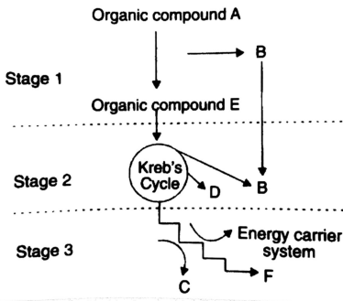
1.4.1 Identify the following:
- stage 1 (1)
- stage 3 (1)
- The organic compound A (1)
- The energy rich atom B (1)
- The energy rich substance B (1)
- The gas D (1)
- The organic compound E (1)
- The by-product F (1)
1.4.2 In which organelle do stage 1 and 2 occur? (1)
1.4.3 State where in a cell does stage 1 occur? (1)
1.4.4 State what happens to compound E if no oxygen is
present (2)
(12)
TOTAL SECTION A: 50
SECTION B
QUESTION 2
2.1 The following diagram illustrates some investigations carried out on
photosynthesis. The plant was kept in the dark for 48 hours before
being placed in sunlight.
Study the diagram and then answer the questions that follow.

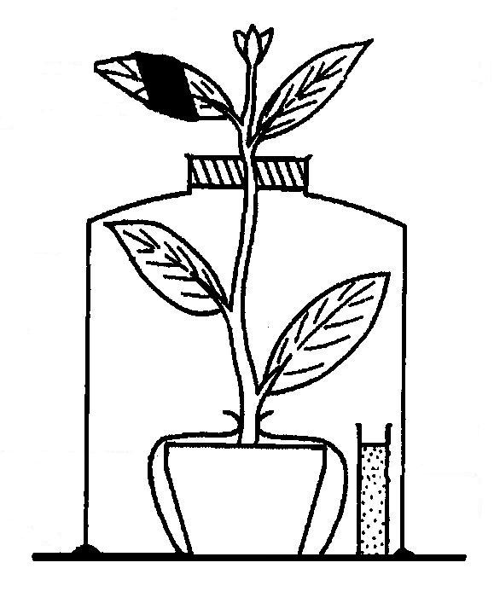
leaf C
aluminium foil
leaf B
leaf A
Potassium hydroxide solution

2.1.1 State the aim of the following experiments
- Leaf A (1)
- Leaf B (1)
2.1.2 Explain why the plant was kept in the dark for 48 hours
before being placed in sunlight (2)
2.1.3 Starch tests were carried on the three leaves. Name the
chemical reagent that was used to test for the presence of
starch (1)
2.1.4 Tabulate the result of Leaf A, Leaf B and Leaf C (3)
2.1.5 Provide a reason the result of starch test on Leaf A (2)
(10)
2.2 Study the diagram of the parts of human digestive system and
answer the questions that follow

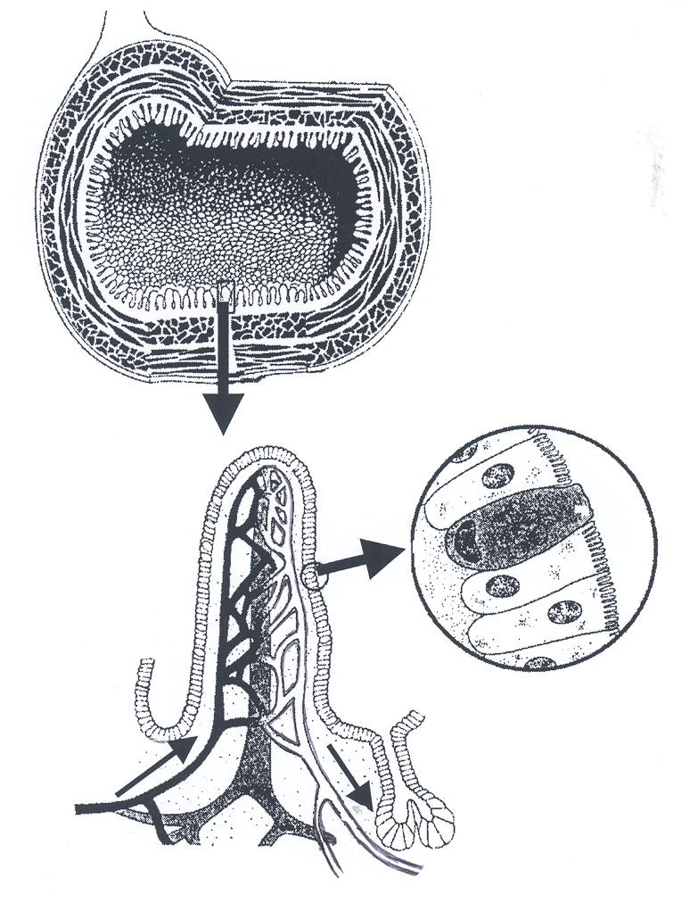
X
Diagram II
Diagram III
E
Diagram I
Y
G

F
D
C
B
A

II
2.2.1 Through which part of the alimentary canal is the section
represented by diagram made (1)
2.2.2 Provide labels for part A, C and D (3)
2.2.3 State the function of D (1)
2.2.4 Explain two ways visible in the diagram, in which the part
represented by Diagram II is suited for its function (4)
2.2.5 State the letter that represent the vessels that transports
the end product of fat digestion (1)
2.2.6 Identify vessel
2.2.7 Name two digestive products which are mainly absorbed
vessel X (2)
(12)
2.3 Study the diagram below showing body plan of different
organism and answer the questions that follow:
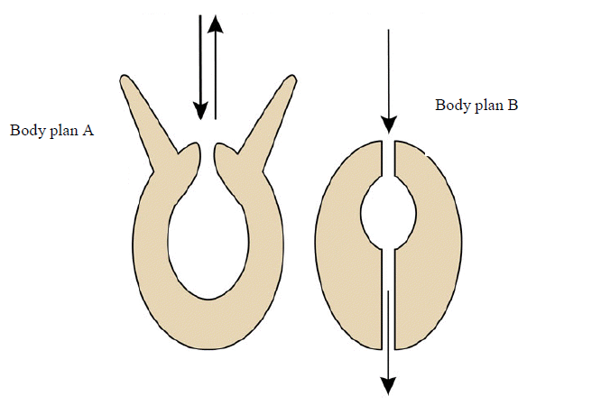
2.3.1 Identify the type of digestive system found in animals with
body plan A and B (2)
2.3.2 Explain the disadvantage of the gut illustrated by the body
plan A (2)
2.3.3 Identify two organism which has the type of digestive
system represented by body plan A (2)
2.3.4 State the two significance of the type of digestive system
represented by the body plan B (4)
2.3.5 State the advantage of the presence of coelom to the
animals that has the body plan B (2)
(10)
2.4 The graph below shows the level of antibody in the blood after
two injections of vaccine.
2.4.1 Define the following terms:
- antibody (1)
- antigen (1)
- immunity (1)
2.4.2 Give a reason why the second response of vaccination is
faster and greater than the first response (2)
2.4.3 Explain how the natural response shown in the graph has
been used successfully to create artificial active immunity
in humans (3)
(8)
TOTAL QUESTION 2: [40]
QUESTION 3
3.1 The following graph shows the result of an experiment to determine
the effect of different light intensities, temperature and CO₂
concentration on the rate of photosynthesis in the plant
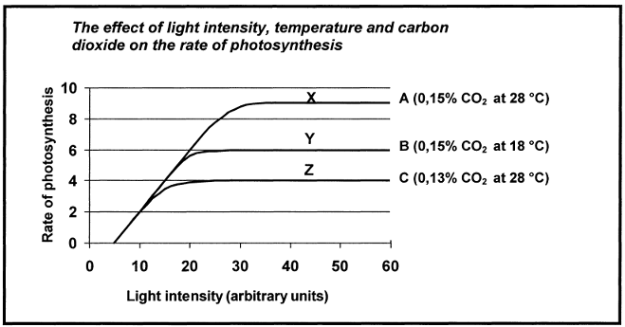
3.1.1 Explain the effect of different light intensities on the rate of
photosynthesis (3)
3.1.2 Explain the difference in the rate of photosynthesis on the
rate of the following:
- X and Y (3)
- X and Z (3)
(9)

3.2 Study the diagram below of digestive system and answer the
questions that follow:

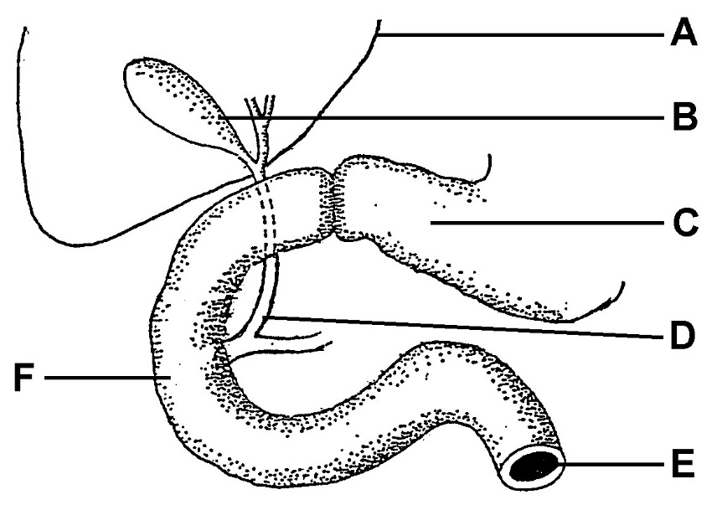

3.2.1 Label the part D and F (2)
3.2.2 State the name of the digestive juice found in C (1)
3.2.3 Name and state the function of the enzyme s produced in
part C (2)
3.2.4 State Three nutritive functions of the organ marked A (3)
3.2.5 By what process is food moved down part E (1)
3.2.6 State two functions of the liquid stored in B (2)
(11)
3.3 The grade 11 leaners conducted an experiment to investigate the
rate of photosynthesis in a submerged plant. The light intensity
to which the plant is subjected, was decreased at regular
intervals by moving the light source away from the plant. The
average number of bubbles released per minute, was counted
for each distance. These are the results obtained from an
investigation of the rate of photosynthesis.

Distance from the lamp (cm) | 5 | 10 | 20 | 25 | 35 | 40 | 50
Number of bubbles per minute | 72 | 66 | 41 | 25 | 16 | 5 | 2

3.3.1 Draw the line graph using the information in the table (7)
3.3.2 Describe the relationship between gas released and light
intensity (2)
3.3.3 Formulate the hypothesis for this investigation (2)
3.3.4 State two variables which must be kept constant during this
investigation (1)
3.3.5 Provide a conclusion for this investigation (1)
(12)

3.4 Study the phylogenetic tree below and answer the questions
that follow: 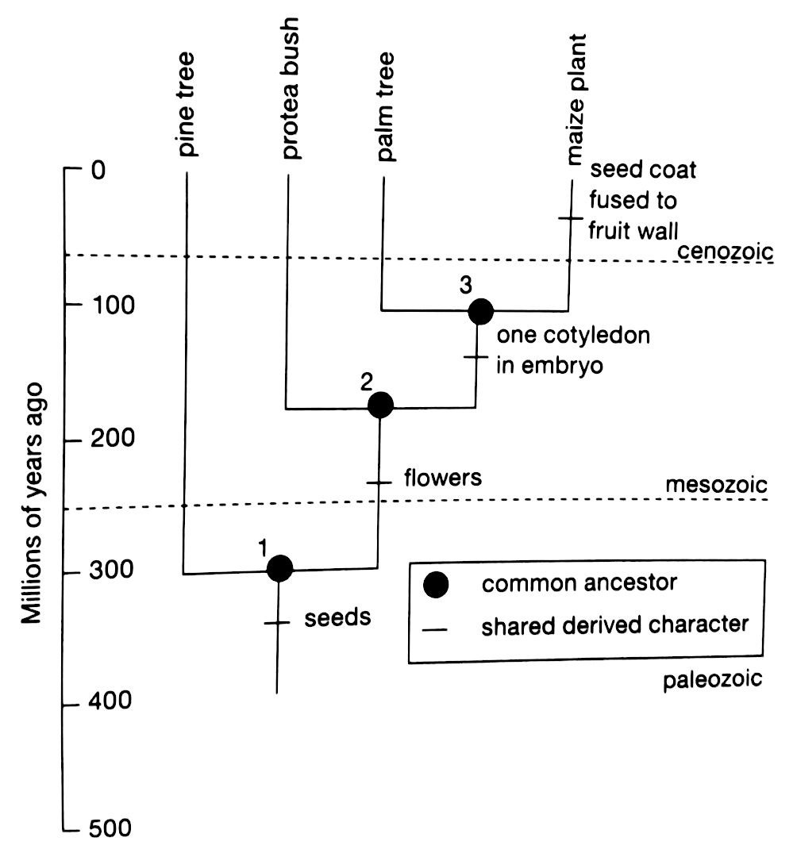
3.4.1 State the number which represent the common ancestor of
the flowering plants (1)
3.4 2 Identify the plant species that is closely related to protea
bush. Provide reason for your answer (3)
3.4.3 Name all characteristics shared by the palm tree and
maize plant (3)
3.4.3 State how many million years ago the ancestor of the
palm tree and maize diverged (1)
(8)
TOTAL QUESTION 3 [40]
TOTAL SECTION B: 80
SECTION C
QUESTION 4
Discuss how plants are adapted to different pollinating agents and as well as the role of microorganisms in maintain balance in the environment
Content: (17)
Synthesis: (3)
(20)
NOTE: No marks will be awarded to answers given in the form of flow
charts, tables or diagrams

TOTAL SECTION C: 20
GRAND TOTAL: 150

