

GRADE 11

LIFE SCIENCES

JHB CLUSTER COMMON EXAM

MARKS: 150 MARKS

TIME: 2,5 hrs

SECTION A

QUESTION 1

  - Various possible options are provided as answers to the following questions.
Choose the answer and write only the letter (A –D) next to the question number.

    - The gametophyte generation in a fern plant changes to the sporophyte generation by…
A fertilisation
B. meiosis
C. asexual reproduction
D fusion of spores

1.1.2 The male cone differs from the female cone in the pine in that...
- Only the male cone bears ovules
- The male cones are small and clustered A
- The female cones are smaller than the male cones
- Male cones have a three year duration

    - Seed producing plants are...
- Spermatophytes
- Angiosperms only
- Gymnosperms only
- Gymnosperms and mosses

    - Gymnosperms and angiosperms are similar in that both....
- Have double fertilisation
- Produce archegonia with a single haploid ovum
- Produce seeds
- Produce seeds enclosed in a fruit

1.1.5 The class of arthropods that have 5 pairs of legs and 2 body divisions are:
A Insecta
B Crustacea
C Arachnida
D Myriapoda

1.1.6. This phylum is characterised by their nematoblasts / stinging cells …
A Annelida
B Arthropoda
C Platyhelminthes
D Cnidaria

1.1.7. The significance of photosynthesis to living organisms is the production of …?

A CO₂ and water
B O₂ and glucose
C glucose and starch
D water and glucose ( 7X2=14)

  - Provide the correct BIOLOGICAL TERM for each of the following statements.

1.2.1 Inoganic compound acting as an energy carrier in cells
1.2.2 The transfer of ripe pollen from a ripe anther to a receptive ripe stigma
1.2.3. The collective name for a filament and an anther
1.2.4 The collective name for an ovary, style and stigma
1.2.5 The tough outer coat of a seed
1.2.6 Reproductive structure in breadmould
1.2.7 Mass of fungal threads
1.2.8 The part of the plant embryo that develops into the root
1.2.9. Organelle in which cellular respiration occurs
1.2.10 Acquired immunity obtained through artificial means via a weakened form of the pathogen
(10X2=20)
  - Indicate whether each of the STATEMENTS in COLUMN I refers to Item A only, Item B only, Both A and B or None of A and B in COLUMN II.

 | COLUMN I | COLUMN II
1.3.1. | Microscopic structure in digestive system responsible for absorption of digested food products | A small intestine  B villi
1.3.2. | Fungal infections | A athletes foot  B thrush
1.3.3. | Psychological nutritional disorders | A Bulimia  B Marasmus
1.3.4. | Used in bread and beer making industries | A Anaerobic respiration  B Aerobic respiration
1.3.5. | Anaerobic respiration | A Kreb’s cycle  B Glycolysis
1.3.6. | Products of aerobic respiration | A carbon dioxide  B ethanol
1.3.7 | Requirements essential for photosynthesis | A chlorophyll  B carbon dioxide
1.3.8 | Chemical used to test for starch in leaves | A iodine solution  B ethanol

(8X2=16)

TOTAL SECTION A : 50 MARKS

SECTION B
QUESTION 2

2.1 Study the table below showing the prevalence of influenza amongst learners in a high school in Limpopo Province. There were a total of 325 boys and 392 girls in the school during the period of the survey.

Month | Boys infected with influenza | Girls infected with influenza
April | 5 | 17
May | 32 | 59
June | 71 | 88
July | 65 | 75
August | 10 | 5

2.1.1 Give one reason why girls had a higher rate of infection than boys. (2)

2.1.2 What percentage of boys was infected by the influenza virus in July?
Show all calculations. (3)

2.1.3 A flu vaccine was administered in July. Was it effective?
Justify your answer. (3)

2.1.4 Why would these learners need to be vaccinated every year to reduce the risk of
getting influenza? (2)
(10)
2.2. Khaylitsha was home to over half a million people in 2007. This area lies on the outskirts of Cape Town. Water comes from shared taps, as one in three people have no access to water at his or her home. The population is growing by 48 000 people every year. The area is divided into regions called site A, site B and site C. Research in site B and C shows that there is one toilet for every 105 people. The table that follows lists the top four causes of death for children under the age of one in the area. Note that diarrhoea did not feature as a cause of death in any of the middle-class or upper class suburbs of Cape Town.

Table showing the top four causes of death among children under one years old in 2008 and 2010 in Khaylitsha

Category | 2008 | 2010
Diarrhoea and gastro-enteritis | 19,2% | 21,3%
HIV/AIDS | 11,7% | 16,1%
Pneumonia | 9,2% | 6,6%
TB | 8,9% | 13,3%

2.2.1. Plot a bar graph of the data provided. (14)
2.2.2.Which positive trend took place between 2008 and 2010 (according to the data)?(2)
2.2.3.Does this data suggest a link between HIV/AIDS and TB? Explain your answer. 3)
2.2.4.In what scientific way could this data have been collected? (1)
(20)

QUESTION 3
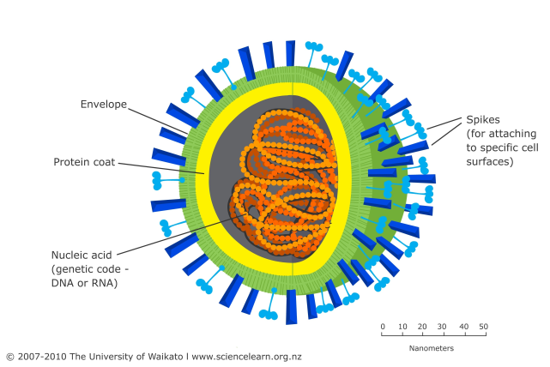
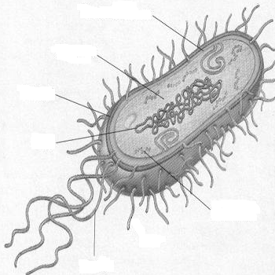
3.1. Examine the micro-organisms below and answer the questions that follow.

A (boundary)
B
C
F
E
DIAGRAM 1
DIAGRAM 2

D

3.1.1 Identify the types of organisms shown in diagram 1 and 2 respectively (2)

3.1.2 Give the letter of the part to which each of the following refers:
(i) plasmids
(ii) consists of proteins (2)

3.1.3 Which organism (diagram 1 or 2) would cause tuberculosis? (1)

3.1.4 Briefly explain TWO ways in which the government could improve public health and prevent
deaths due to diseases like tuberculosis. (4)

    - Make a labelled diagram of a bacterium (6)
[15]
  - Examine the diagram below and answer the questions that follow:
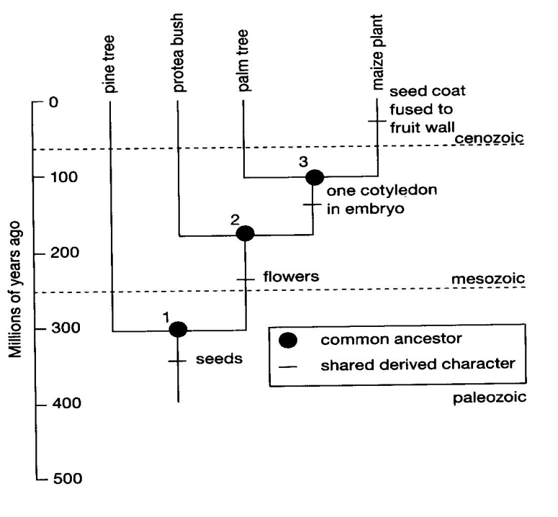
3.2.1. Provide a definition for a phylogenetic tree. (2)
3.2.2. Which number indicate the common ancestor for maize and palm trees ? (2)
3.2.3. In which era did seed bearing plants first appear ? (2)
3.2.4. How many millions of years ago did the protea bush first arise ? (2)
3.2.5. Provide a single term for plants with only one cotyledon . (2)
[10]
3.3. You have studied 4 plant groups, viz. Bryophytes, Pterophytes, Gymnosperms and
Angiosperms.
Complete the table below based on the four listed features used to separate plants into
these groups.

PLANT DIVERSITY | 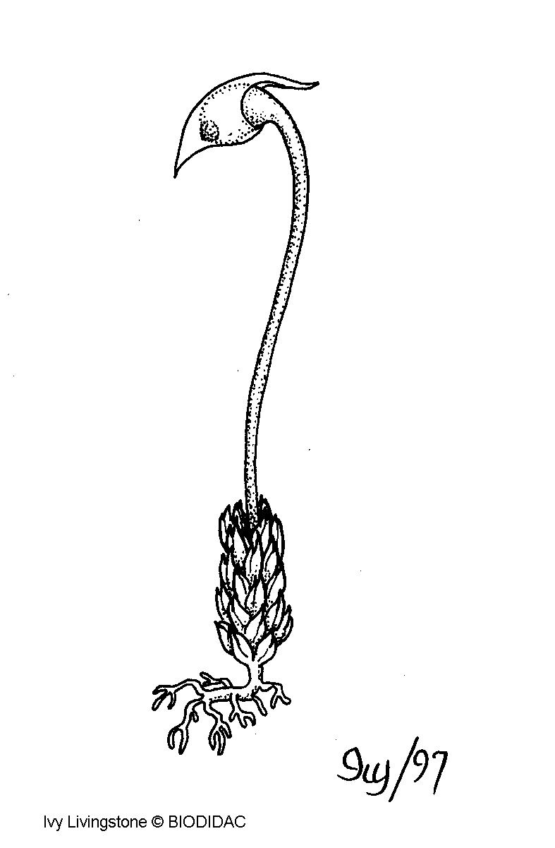 | 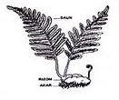 | 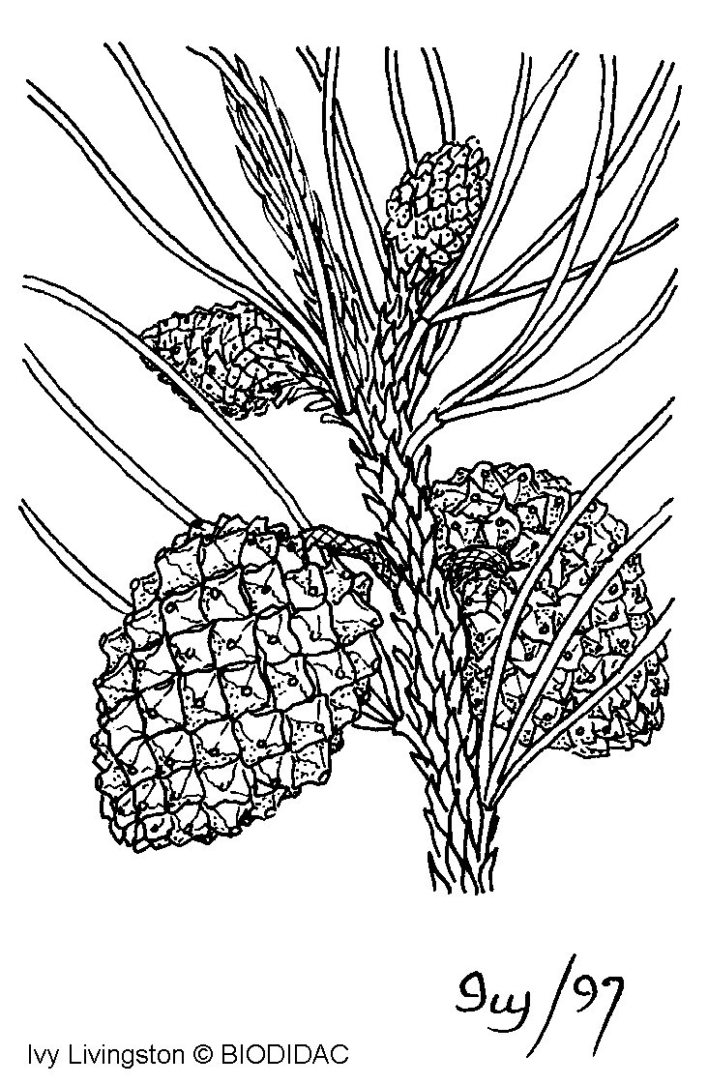 | 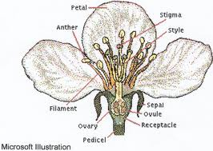
PLANT DIVISION | 3.3.1. | 3.3.2. | Gymnosperms | Angiosperms
COMMON NAME | moss | 3.3.3. | 3.3.4 | Flowering plant
VASCULAR TISSUE | absent | 3.3.5. | 3.3.6 | present
SPORES/SEEDS | 3.3.7. | spores | seeds | 3.3.8.
THALLUS / TRUE ROOTS & LEAVES | thallus | 3.3.9. | true roots & leaves | true roots & leaves
WATER DEPENDENCY FOR REPRODUCTION | 3.3.10. | 3.3.11. | yes | 3.3.12.
Write only the missing word / phrase that is missing next to the appropriate number.
[12]

3.4.Fill in the missing words related to the specific criteria in the following comparative table on
animal diversity.

TYPE OF ORGANISM | 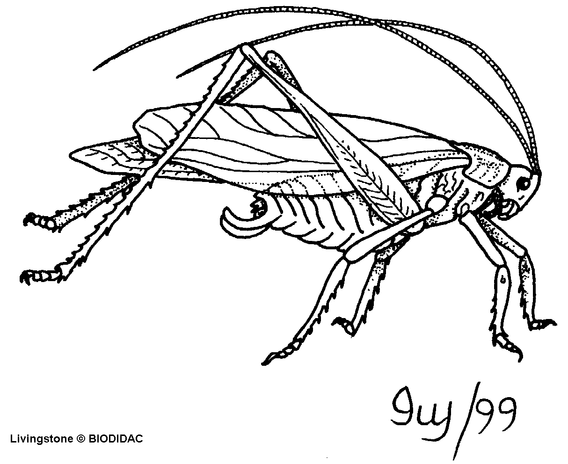 | 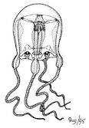 | 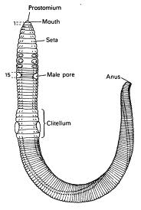 | 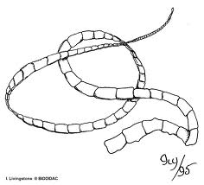
Phylum | Arthropoda | 3.4.1 | 3.4.2. | Plathelminthes
Example | 3.4.3. | Sponges | 3.4.4. | 3.4.5
Type of symmetry | 3.4.6 | radial | bilateral | 3.4.7.
Coelomate/Acoelomate | 3.4.8 | coelomate | 3.4.9. | 3.4.10
No. of body layers | 3.4.11 | 3.4.12 | 3.4.13 | triploblastic

[13]

TOTAL SECTION B : 80 MARKS

SECTION C
QUESTION 4

4.1. Briefly describe the pathway and processes of ingestion , digestion , absorption and assimilation involved when a person has eaten a buttered polony sandwich. ( 17)

Synthesis : 3

TOTAL SECTION A : 20 MARKS

GRAND TOTAL : A(50)+B(80)+C(20) = 150 MARKS

